# Package Installation Guide

## Step by step guide to install and update packages

This section will detail the system requirements and UiPath packages to be available in the system to ensure that it executes the codes correctly. Follow the steps to install the package in UiPath studio:

**Step 1.** Click on Manage Packages.

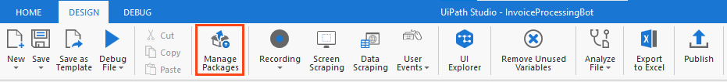

Figure 1 Manage Packages Ribbon Bar

**Step 2.** Search the package according to the project requirement.

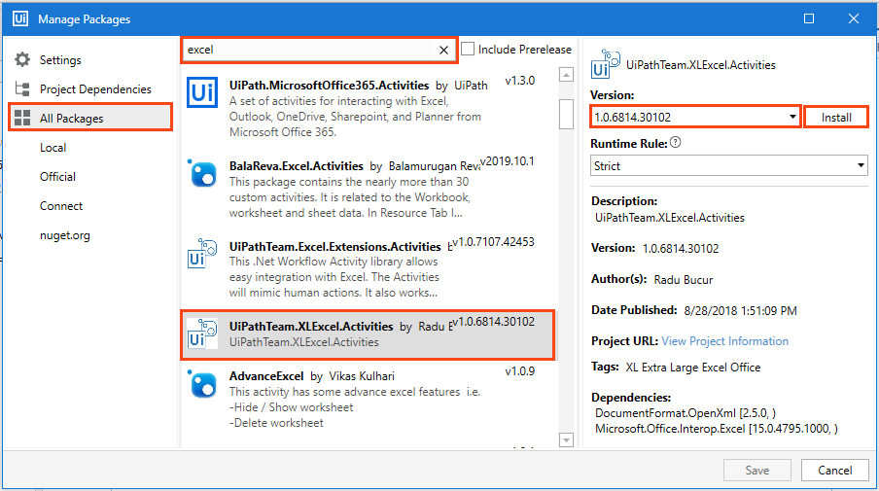

Figure 2 Package Installation

**Step 3:** Select the package and the version to be installed.

**Step 4:** Save the packages by clicking on the “Save” button.

## Viewing list of installed Packages

To view the packages used in code, right-click on the “Dependencies” option of “Project” panel and select “Manage” option (refer Figure 3).

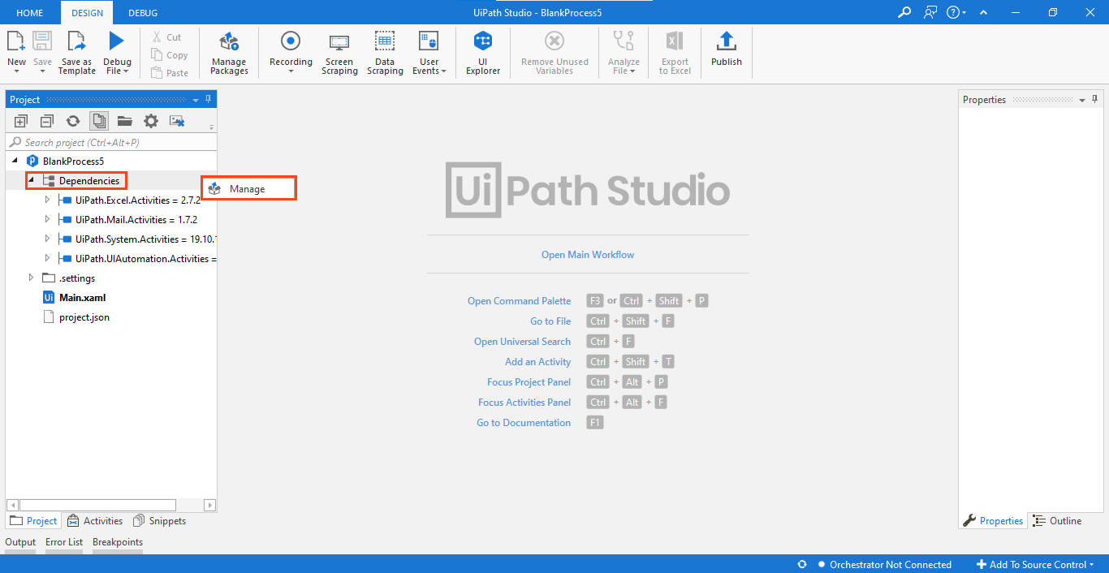

Figure 3 Installed Packages List

Note: For the codes which involve browser usage, the browser should have its extension installed. You can install an extension from the 'Tools' section of UiPath Studio.

# Advanced Projects

## Stock Price Trend Comparison Robot

The code comprises of four packages (refer Table 5) and they must be installed in the studio for the Robot to execute the task successfully.

* UiPath.Excel.Activities
* UiPath.Mail.Activities
* UiPath.System.Activities
* UiPath.UiAutomation.Activities

Table 5 List of Packages used in ‘Stock Price Trend Comparison Robot.'

The above-listed packages used can be viewed on the left side of the "Project" panel tab (refer Figure 12).

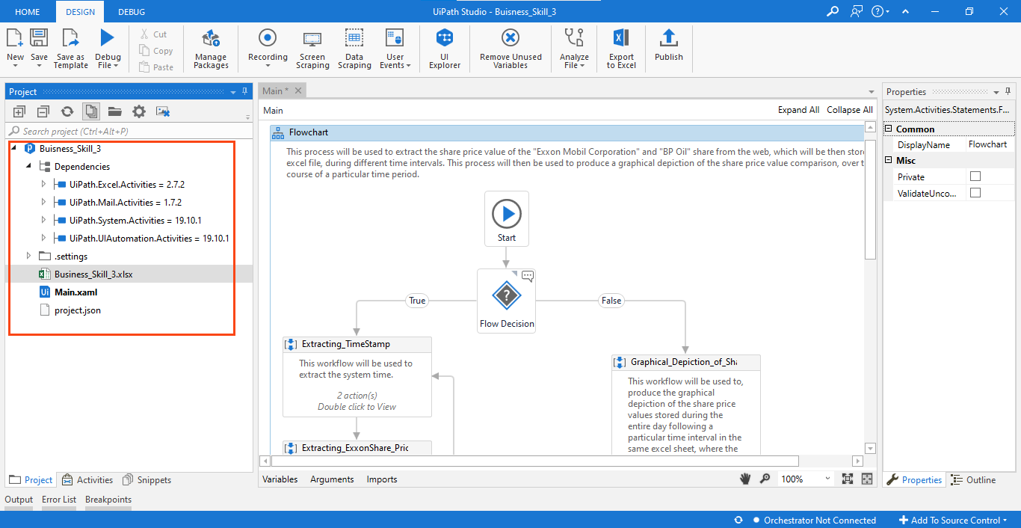

Figure 12 List of Packages used in ‘My SQL Backup Restoring’ Robot

Right-click on "Dependencies" and select "Manage" to view all project dependencies (refer figure 13).

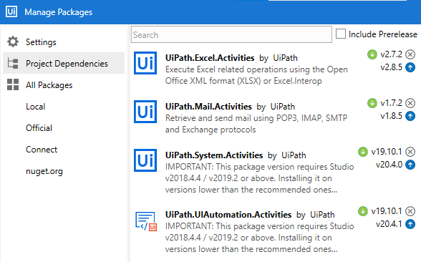

Figure 13 Project Dependencies ‘Stock Price Trend Comparison Robot’

**Note: If a package appears in 'Red' it indicates a problem. To resolve it, right-click on the package name and click resolve/update.**

**Prerequisite:**

* Internet Explorer should be installed in your system device.
* MS Office package should be installed on your system.

‘**Data.xlsx**’ file should be present in the project folder file has been created in advance with the defined three columns in it.

‘Auto Save’ option should be disabled in excel.

## Process Flow

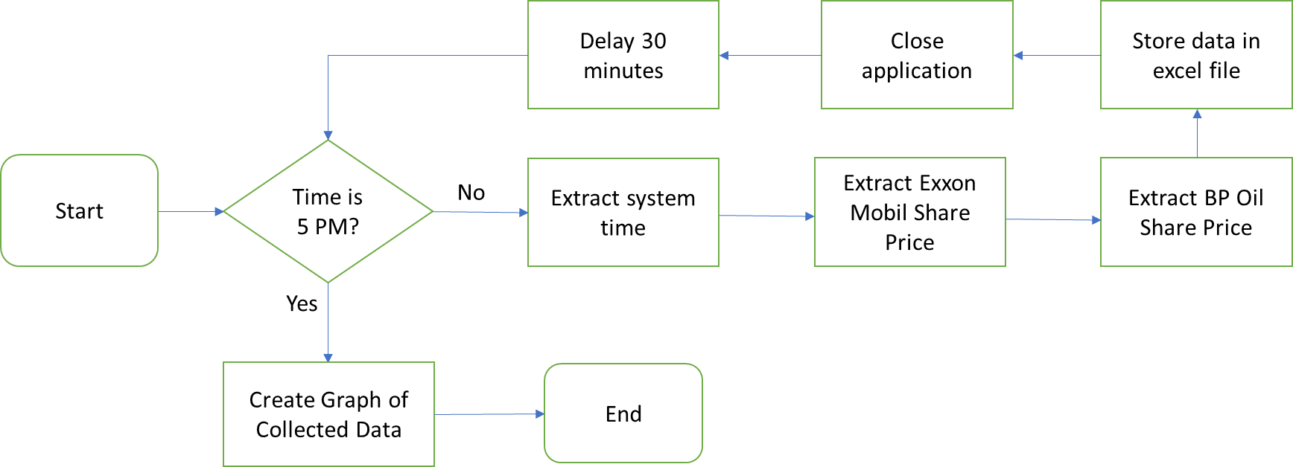

## Applications to be used



1. **UiPath Studio:** Used to create the Robot.
2. **Web Browser:** Used to extract stock price data from stock market website.
3. **MS Excel:** Used to store extracted data and create graph.

## Process steps

**Project Overview:** This project aims to build a Robot to collect share price data of ‘Exxon Mobil Corp.’ and ‘BP Oil’ every day at the interval of 30 minutes and store them in a file. This process continues till 5pm everyday. After 5 pm, the daily collected data gets processed and presented in the form of a graph.

## Steps to make a Stock Price Trend Comparison Robot:

Step 1: The Robot will create a blank excel file, with pre-defined fields.

Step 2: Searches for share price of Exxon Mobil Corp and BP Oil on Google.

Step 3: Selects the share price value field.

Step 4: Extracts the stock value and update the excel.

Step 5: The Robot will continuously keep extracting values from the website for both the variables with time stamp every 30 minutes till 5 PM.

Step 6: The Robot creates a graph with the extracted value after 5 PM.

## Appendix

**1. What is Stock?**

Stock is the shares in which the ownership of a company or corporation is divided. Shares are small portion of the company that gives you a small ownership in the company.

**2. What is Share Market?**

The share market is where shares of various companies are sold or purchased.